Customization of Lighting and Ventilation system in household
Code
Data Collection – Arduino code
#include <ESP8266WiFi.h>
#include "ThingSpeak.h" // always include thingspeak header file after other header files and custom macros
char ssid[] ="Project"; // your network SSID (name)
char pass[] = "12345678"; // your network password
int keyIndex = 0; // your network key Index number (needed only for WEP)
WiFiClient client;
#include "DHTesp.h"
#include <Adafruit_ADS1X15.h>
int ldr=0;
#include <LCD_I2C.h>

LCD_I2C lcd(0x27);
Adafruit_ADS1115 ads;
float adc_voltage = 0.0;
float in_voltage = 0.0;

String st="";
// Floats for resistor values in divider (in ohms)
float R1 = 30000.0;
float R2 = 7500.0;

// Float for Reference Voltage
float ref_voltage = 5.0;

// Integer for ADC value
int adc_value = 0;

#ifdef ESP32
#pragma message(THIS EXAMPLE IS FOR ESP8266 ONLY!)
#error Select ESP8266 board.
#endif

DHTesp dht;

int count = 0;

void setup() {
pinMode(D5,OUTPUT);
pinMode(D6,OUTPUT);
//digitalWrite(D6,HIGH);
pinMode(A0,INPUT);
Serial.begin(9600);
lcd.begin(); // If you are using more I2C devices using the Wire library use lcd.begin(false)
// this stop the library(LCD_I2C) from calling Wire.begin()
lcd.backlight();
lcd.setCursor(0, 0);
lcd.print("HOME"); // You can make spaces using well... spaces
lcd.setCursor(0, 1); // Or setting the cursor in the desired position.
lcd.print("MONITORING");
delay(2500);
lcd.clear();
if (!ads.begin()) {
Serial.println("Failed to initialize ADS.");
while (1);
}
dht.setup(D0, DHTesp::DHT11);
WiFi.mode(WIFI_STA);
ThingSpeak.begin(client);
if(WiFi.status() != WL_CONNECTED){

while(WiFi.status() != WL_CONNECTED){
WiFi.begin(ssid, pass); // Connect to WPA/WPA2 network. Change this line if using open or WEP network
Serial.print(".");
delay(5000);
}
Serial.println("\nConnected.");
}
}

void loop() {
ldr=analogRead(A0);
delay(dht.getMinimumSamplingPeriod());
ldr=ldr/250;
float humidity = dht.getHumidity();
float temperature = dht.getTemperature();
lcd.setCursor(0, 0);
lcd.print("TEMPERATURE"); // You can make spaces using well... spaces
lcd.setCursor(0, 1); // Or setting the cursor in the desired position.
lcd.print(temperature);
delay(500);
lcd.clear();

int16_t adc0, adc1, adc2, adc3;
float volts0, volts1, volts2, volts3;

adc0 = ads.readADC_SingleEnded(0);
adc1 = ads.readADC_SingleEnded(1);
adc2 = ads.readADC_SingleEnded(2);
adc3 = ads.readADC_SingleEnded(3);
adc0=adc0/4000;
adc1=adc1/4000;
analogWrite(D5,(adc0*4));
analogWrite(D6,(adc1*40));
if(ldr==0)
{
ldr=1;
}
volts0 = ads.computeVolts(adc0);
volts1 = ads.computeVolts(adc1);
volts2 = ads.computeVolts(adc2);
volts3 = ads.computeVolts(adc3);
Serial.println(adc0);
lcd.setCursor(0, 0);
lcd.print("POT-1"); // You can make spaces using well... spaces
lcd.setCursor(0, 1); // Or setting the cursor in the desired position.
lcd.print(adc0);
delay(500);
lcd.clear();
lcd.setCursor(0, 0);
lcd.print("POT-2"); // You can make spaces using well... spaces
lcd.setCursor(0, 1); // Or setting the cursor in the desired position.
lcd.print(adc1);
delay(500);
lcd.clear();
lcd.setCursor(0, 0);
lcd.print("LDR"); // You can make spaces using well... spaces
lcd.setCursor(0, 1); // Or setting the cursor in the desired position.
lcd.print(ldr);
delay(500);
lcd.clear();
Serial.println(adc1);
ThingSpeak.setField(1,temperature );
ThingSpeak.setField(2,ldr);
ThingSpeak.setField(3,adc0);
ThingSpeak.setField(4,adc1);
int xrt = ThingSpeak.writeFields(2049359, "6Y4L3ZDOATSXYZYM");

}

Training Machine learning classifiers – Python Code
K-Nearest Neighbours
import numpy as np
import pandas as pd
from sklearn import metrics
from sklearn.model_selection import train_test_split
import matplotlib.pyplot as plt
import seaborn as sns
import pickle
a=int(input("Enter 1 for fan train 2 for light"))
if a==1:
m="data_fan.csv"
else:
m="data_light.csv"
data = pd.read_csv(m)
data.head()
data.shape
X = data.iloc[:,:-1]
X.head()
y = data.iloc[:,-1]
y.head()
data['Target'].value_counts()
X_train,X_test,y_train,y_test = train_test_split(X,y,test_size=0.3,random_state=1)
sns.countplot(x='Target',data=data)
plt.show()
X_train.shape
X_train.head()
y_test.shape
y_test.head()
from sklearn.metrics import accuracy_score
max_accuracy = 0

from sklearn.neighbors import KNeighborsClassifier

for x in range(1,32):
model = KNeighborsClassifier(n_neighbors=x)
model.fit(X_train,y_train)
y_pred = model.predict(X_test)
current_accuracy = round(accuracy_score(y_pred,y_test)*100,2)
if(current_accuracy>max_accuracy):
max_accuracy = current_accuracy
best_x = x

#print(max_accuracy)
#print(best_x)

model = KNeighborsClassifier(n_neighbors=best_x)
model.fit(X_train,y_train)
y_pred = model.predict(X_test)
if a==1:
filename = 'knnfan.sav'
else:
filename = 'knnlight.sav'
pickle.dump(model, open(filename, 'wb'))
acc=(metrics.accuracy_score(y_pred,y_test)*100)
print("Accuracy is:",acc)

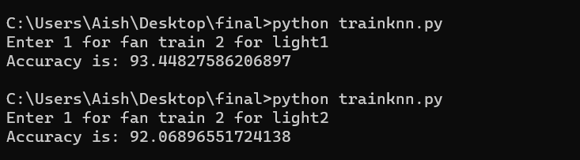

Support Vector Machine
import numpy as np
import pandas as pd
from sklearn import metrics
from sklearn.model_selection import train_test_split
import matplotlib.pyplot as plt
import seaborn as sns
import pickle
a=int(input("Enter 1 for fan train 2 for light"))
if a==1:
m="data_fan.csv"
else:
m="data_light.csv"
data = pd.read_csv(m)
data.head()
data.shape
X = data.iloc[:,:-1]
X.head()
y = data.iloc[:,-1]
y.head()
data['Target'].value_counts()
X_train,X_test,y_train,y_test = train_test_split(X,y,test_size=0.3,random_state=1)
sns.countplot(x='Target',data=data)
plt.show()
X_train.shape
X_train.head()
y_test.shape
y_test.head()

from sklearn.svm import SVC
model = SVC(kernel='linear')
model.fit(X_train,y_train)
if a==1:
filename = 'svmfan.sav'
else:
filename = 'svmlight.sav'
pickle.dump(model, open(filename, 'wb'))
y_pred = model.predict(X_test)
acc=(metrics.accuracy_score(y_pred,y_test)*100)
print("Accuracy is:",acc)
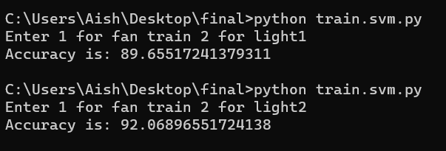

Random Forest
import numpy as np
import pandas as pd
from sklearn import metrics
from sklearn.model_selection import train_test_split
import matplotlib.pyplot as plt
import seaborn as sns
import pickle
a=int(input("Enter 1 for fan train 2 for light"))
if a==1:
m="data_fan.csv"
else:
m="data_light.csv"
data = pd.read_csv(m)
data.head()
data.shape
X = data.iloc[:,:-1]
X.head()
y = data.iloc[:,-1]
y.head()
data['Target'].value_counts()
X_train,X_test,y_train,y_test = train_test_split(X,y,test_size=0.3,random_state=1)
sns.countplot(x='Target',data=data)
plt.show()
X_train.shape
X_train.head()
y_test.shape
y_test.head()
from sklearn.ensemble import RandomForestClassifier
from sklearn.metrics import accuracy_score
max_accuracy = 0

for x in range(10):
rf = RandomForestClassifier(random_state=x)
rf.fit(X_train,y_train)
y_pred_rf = rf.predict(X_test)
current_accuracy = round(accuracy_score(y_pred_rf,y_test)*100,2)
if(current_accuracy>max_accuracy):
max_accuracy = current_accuracy
best_x = x

#print(max_accuracy)
#print(best_x)

rf = RandomForestClassifier(random_state=best_x)
rf.fit(X_train,y_train)
Y_pred_rf = rf.predict(X_test)
if a==1:
filename = 'randomforestfan.sav'
else:
filename = 'randomforestlight.sav'
pickle.dump(rf, open(filename, 'wb'))
acc=(metrics.accuracy_score(y_pred_rf,y_test)*100)
print("Accuracy is:",acc)
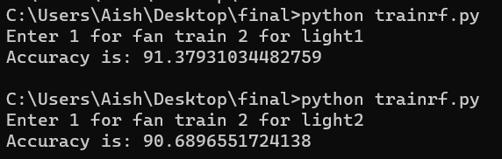

Naïve Bayes
import numpy as np
import pandas as pd
from sklearn import metrics
from sklearn.model_selection import train_test_split
import matplotlib.pyplot as plt
import seaborn as sns
import pickle
a=int(input("Enter 1 for fan train 2 for light"))
if a==1:
m="data_fan.csv"
else:
m="data_light.csv"
data = pd.read_csv(m)
data.head()
data.shape
X = data.iloc[:,:-1]
X.head()
y = data.iloc[:,-1]
y.head()
data['Target'].value_counts()
X_train,X_test,y_train,y_test = train_test_split(X,y,test_size=0.3,random_state=1)
sns.countplot(x='Target',data=data)
plt.show()
X_train.shape
X_train.head()
y_test.shape
y_test.head()

from sklearn.naive_bayes import GaussianNB
model = GaussianNB()
model.fit(X_train,y_train)
if a==1:
filename = 'naivefan.sav'
else:
filename = 'naivelight.sav'
pickle.dump(model, open(filename, 'wb'))
y_pred = model.predict(X_test)
acc=(metrics.accuracy_score(y_pred,y_test)*100)
print("Accuracy is:",acc)
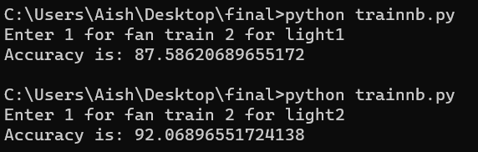

Decision Tree
import numpy as np
import pandas as pd
from sklearn import metrics
from sklearn.model_selection import train_test_split
import matplotlib.pyplot as plt
import seaborn as sns
import pickle
a=int(input("Enter 1 for fan train 2 for light"))
if a==1:
m="data_fan.csv"
else:
m="data_light.csv"
data = pd.read_csv(m)
data.head()
data.shape
X = data.iloc[:,:-1]
X.head()
y = data.iloc[:,-1]
y.head()
data['Target'].value_counts()
X_train,X_test,y_train,y_test = train_test_split(X,y,test_size=0.3,random_state=1)
sns.countplot(x='Target',data=data)
plt.show()
X_train.shape
X_train.head()
y_test.shape
y_test.head()

from sklearn.tree import DecisionTreeClassifier
from sklearn.metrics import accuracy_score
model = DecisionTreeClassifier()
model.fit(X_train,y_train)
if a==1:
filename = 'dtfan.sav'
else:
filename = 'dtlight.sav'
pickle.dump(model, open(filename, 'wb'))
y_pred = model.predict(X_test)
acc=(accuracy_score(y_pred,y_test)*100)
print("Accuracy is:",acc)
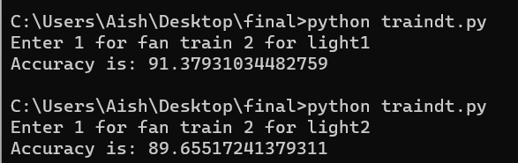

Face recognition and final working automated fan and light – Python Code
import urllib.request
import http
from time import sleep
import face_recognition
import cv2
from time import sleep
from openpyxl import Workbook
import datetime
import csv
import json
import time
import os
import urllib.request
import time
import os
import serial
base = "http://192.168.43.157/"
name=""
xyu=""
top = 4
right = 4
bottom = 4
left = 4

image_1 = face_recognition.load_image_file("Iswarya.jpeg")
image_1_face_encoding = face_recognition.face_encodings(image_1)[0]
image_2 = face_recognition.load_image_file("Anju.jpg")
image_2_face_encoding = face_recognition.face_encodings(image_2)[0]

known_face_encodings = [
image_1_face_encoding,
image_2_face_encoding
]
known_face_names = ["Iswarya","Anju"]
face_locations = []
face_encodings = []
face_names = []
video_capture = cv2.VideoCapture(0)
first_match_index="9"
gy=0
facei=0
while True:
process_this_frame = True
ret, frame = video_capture.read()
small_frame = cv2.resize(frame, (0, 0), fx=0.25, fy=0.25)
rgb_small_frame = small_frame[:, :, ::-1]
name=""
if process_this_frame:
face_locations = face_recognition.face_locations(rgb_small_frame)
face_encodings = face_recognition.face_encodings(rgb_small_frame, face_locations)
print(len(face_encodings))
first_match_index=9
for face_encoding in face_encodings:
matches = face_recognition.compare_faces(known_face_encodings, face_encoding)
name = "Unknown"
cv2.imwrite("temp.jpg",frame)
if True in matches:
first_match_index = matches.index(True)
print(first_match_index)
name = known_face_names[first_match_index]
face_names.append(name)
process_this_frame = not process_this_frame
for (top, right, bottom, left), name in zip(face_locations, face_names):
top *= 4
right *= 4
bottom *= 4
left *= 4
cv2.rectangle(frame, (left, top), (right, bottom), (0, 0, 255), 2)
cv2.rectangle(frame, (left, bottom - 35), (right, bottom), (0, 0, 255), cv2.FILLED)
font = cv2.FONT_HERSHEY_DUPLEX
cv2.putText(frame, name, (left + 6, bottom - 6), font, 1.0, (255, 255, 255), 1)
cv2.imshow('Video', frame)
face_names=[]
ft=str(first_match_index)
#print(name)
if "Unknown" in name:
facei=0
os.system("python mail.py")
elif "Iswarya" in name:
facei=1
elif "Anju" in name:
facei=2
gy=gy+1
if gy>10:
break
cv2.waitKey(1)
video_capture.release()
cv2.destroyAllWindows()
def transfer(my_url): #use to send and receive data
try:
n = urllib.request.urlopen(base + my_url).read()
n = n.decode("utf-8")
return n

except http.client.HTTPException as e:
return e

#Send this data
g=""
h=""
r=""
ft=""
re=[]*2
k=0
res=""
while True:
two = transfer(str(res))
#print(two)
r=str(two)
print(r)
sleep(1)
k=k+1
it=0
re=[]
if k>1:
for ty in r:
try:
if '-' not in ty:
ft=ft+str(ty)
else:
x=float(ft)
print(it)
re.append(x)
ft=""
it=it+1
if it==2:
break
except:
print("pass")
ft=""
print("TEMPERATURE")
print(re[0])
print("LDR")
print(re[1])
import pickle
filename = 'knnfan.sav'
loaded_model = pickle.load(open(filename, 'rb'))
a=float(re[0])
b=float(re[1])
Current_reports = [[facei,b,a]]
predicted = loaded_model.predict(Current_reports)
print(predicted[0])
h=str(predicted[0])
import pickle
filename = 'knnlight.sav'
loaded_model = pickle.load(open(filename, 'rb'))
a=float(re[0])
b=float(re[1])
Current_reports = [[facei,b,a]]
predicted = loaded_model.predict(Current_reports)
print(predicted[0])
g=str(int(predicted[0]))

res=g+h

